**Frontend Development with React.js**

**Project Documentation**

1. **INTRODUCTION**

* **Project Title:**

FitFlex Fitzz [ Fitness Tracker ]

* **Team Members and Roles:**
* **Team Leader:**

Keerthana. S

**Email ID**: [sac2225cap23@ssacollegechennai.com](mailto:sac2225cap23@ssacollegechennai.com)

* **Team Member 1:**

Keerthana. L

**Email ID:** [sac2225cap22@ssacollegechennai.com](mailto:sac2225cap22@ssacollegechennai.com)

* **Team Member 2:**

Keerthana. J

**Email ID**: [jothi19112004@gmail.com](mailto:jothi19112004@gmail.com)

* **Team Member 3:**

Keerthana. M

**Email ID:** [ayyappa.keerthu2003@gmail.com](mailto:ayyappa.keerthu2003@gmail.com)

**Team Members Roles:**

1. **Keerthana. S**

– Project Manager & UI/UX Designer*

- Managed the overall project workflow and team coordination.

- Designed the *user interface (UI)* to ensure a smooth and intuitive experience.

- Created wireframes, layouts, and visual elements for the app.

1. **Keerthana. L**

– Frontend Developer*

- Developed the *React-based components* for the app.

- Implemented the *Home Page, About Page, and Navigation System*.

- Ensured responsiveness and smooth interactions across all devices.

1. **Keerthana. J**

– Backend & API Integration*

- Handled data management and *API integration* for exercise search.

- Developed functionalities for *searching workouts by body part and category*.

- Ensured efficient data fetching and backend logic.

1. **Keerthana. M**

– Testing & Deployment*

- Conducted *bug testing and debugging* to ensure app stability.

- Managed deployment and optimization for performance.

- Worked on user feedback integration for further improvements.

1. **Project Overview:**

FitFlex Fitzz is a personal fitness companion designed to help users track their workouts, monitor nutrition, and achieve fitness goals through a structured and interactive platform. The app aims to make fitness accessible, enjoyable, and effective for all users, regardless of their experience level.

**FEATURES OF FITFLEX:**

Personalized Workout Plans: AI-driven, goal-based fitness plans (weight loss, muscle gain, endurance, flexibility).

Exercise Library: Diverse workouts (strength, cardio, HIIT, yoga) with step-by-step guides and video demos.

Intuitive and User-Friendly Design: Navigate the app seamlessly with a clean, modern interface designed for optimal user experience and clear exercise selection.

1. **ARCHITECTURE:**

**State Management:**

Context API for global state management.

Local state within components using useState().

**Routing:**

Implemented using React Router for seamless navigation.

Routes: /dashboard, /workouts,

1. **Setup Instructions:**

**Prerequisites:**   
 Ensure you have the following installed:

* Node.js (Latest LTS version)
* npm
* Git

**Installation:**

* Clone the repository:

Github link: <https://github.com/KeerthanaS2905/FitFlex-Fitzz>

* Navigate into the project directory:

cd ss-fitness

* Install dependencies:

npm install

* Start the development server:

npm start

1. 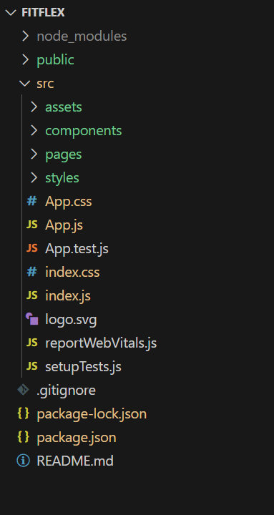**Folder Structure:**

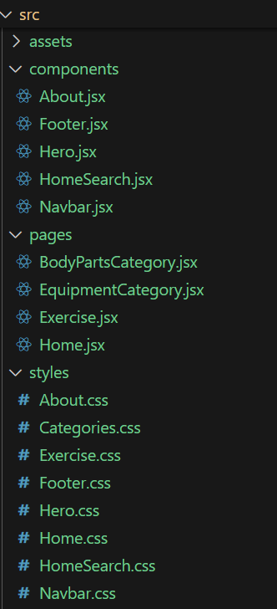

1. **Running the Application:**

To run the project locally, execute:

npm start

1. **Component Documentation**

Key Components:

Dashboard.js: Displays user stats and activity logs.

Workout.js: Shows personalized workout recommendations.

**Reusable Components:**

Button.js: Custom button styling.

Card.js: UI card for displaying fitness data.

**8. State Management**

**Global State**:

Context API is used for managing user authentication and preferences.

**Local State:**

useState() for managing hydration goal input, sleep tracking toggle.

**9. Styling**

CSS Frameworks/Libraries:

Styled-Components for dynamic theming

**10. Screenshots:**

**HOME:** 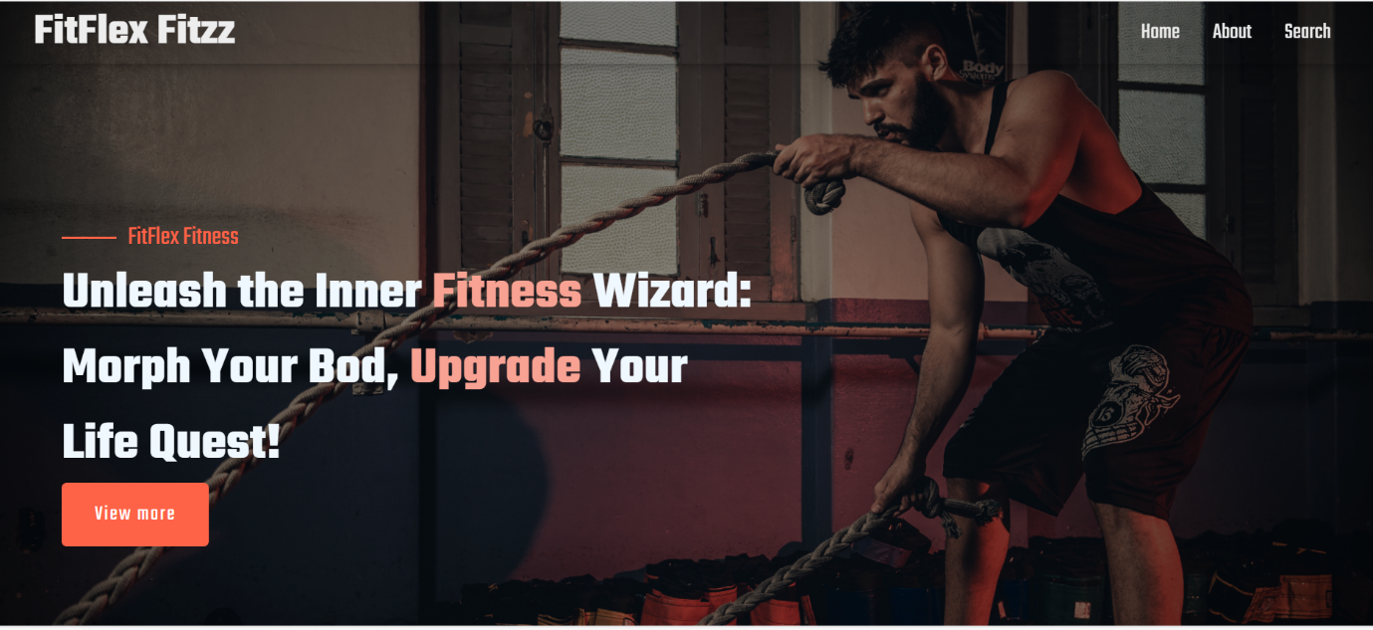

**ABOUT:**

FitFlex Fitzz isn't just another fitness app. We're meticulously designed to transform your workout experience, no matter your fitness background or goals.

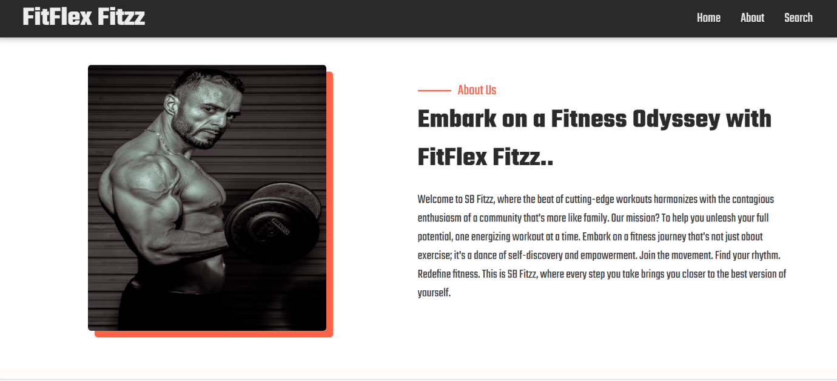

**SEARCH:**

FitFlex Fitzz makes finding your perfect workout effortless. Our prominent search bar empowers you to explore exercises by keyword, targeted muscle group, fitness level, equipment needs, or any other relevant criteria you have in mind. Simply type in your search term and let FitFlex guide you to the ideal workout for your goals.

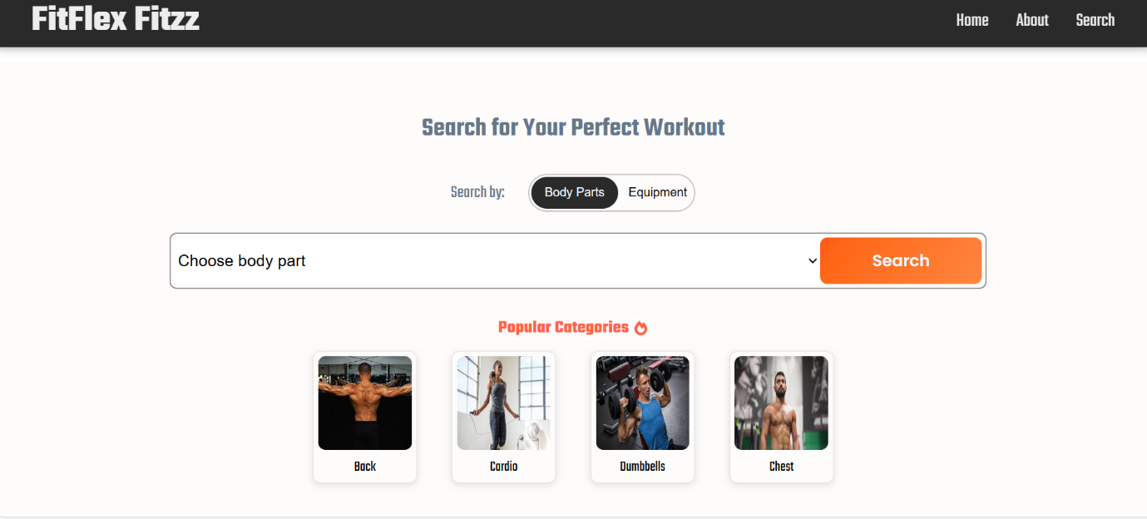

**CATEGORY PAGE:**

FitFlex Fitzz would offer a dedicated section for browsing various workout categories. This could be a grid layout with tiles showcasing different exercise types (e.g., cardio, strength training, yoga) with icons or short descriptions for easy identification.

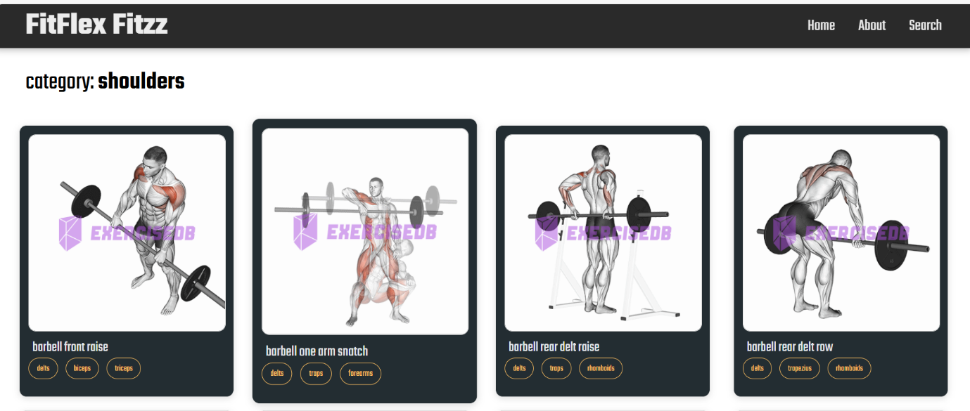

**EXERCISE PAGE:**

This is where the magic happens! Each exercise page on FitFlex provides a comprehensive overview of the chosen workout. Expect clear and concise instructions, accompanied by high-quality visuals like photos or videos demonstrating proper form. Additional details like targeted muscle groups, difficulty level, and equipment requirements (if any) will ensure you have all the information needed for a safe and effective workout.

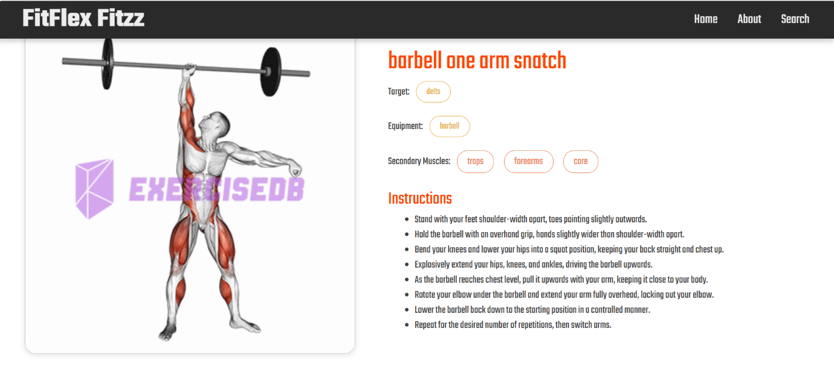

**Demo video link:**

<https://drive.google.com/file/d/1U5g5u3Re5YTeFDaXc9MkfAh7aTgBW-a5/view?usp=drive_link>

**11. Future Enhancements**

AI-Based Fitness Recommendations Integration with Wearable Devices Community Feature for Group Challenges

**12. Code Repository:**

Use the code in:

<https://drive.google.com/file/d/1QKexhOwJK7ZuTAKes8c4FLZ5EejYWiyT/view?usp=drive_link>

**13. Drive link:**

<https://drive.google.com/drive/folders/1PpQokyRFRibQ91uDrW9Mehjw5sea_qad?usp=drive_link>